10

10 3mm red and green LED (common cathode) module

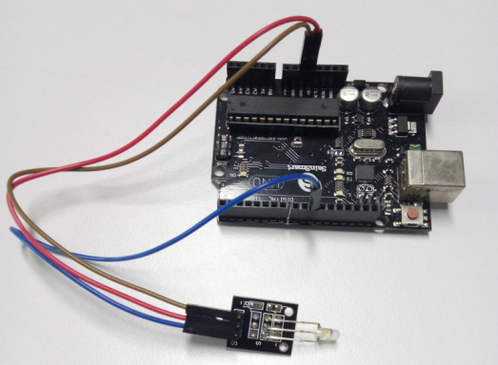

Color: Green + Red

Diameter: 3mm

Case Color: None

Package Type: Diffusion

Voltage (V) :2.0-2 .5

Using a current (MA): 10

Viewing angle: 150

Wavelength (NM): 571 +644

Luminous intensity (MCD) :20-40; 40-80

Stent type: long-legged

Our products are widely used in electronic dictionary, PDA, MP3, headphones, digital cameras,

VCD, DVD, car audio, communications, computers,

Chargers, power amplifier, instrumentation, gifts, electronic toys and mobile phones, and many

other fields.

//Arduino test code:

int redpin = 11; // select the input pin for the potentiometer

int bluepin =10; // select the pin for the LED

int val;

void setup() {

pinMode(redpin, OUTPUT);

pinMode(bluepin, OUTPUT);

Serial.begin(9600);

}

void loop()

{

for(val=255; val>0; val--)

{

analogWrite(11, val);

analogWrite(10, 255-val);

delay(15);

}

for(val=0; val<255; val++)

{

analogWrite(11, val);

analogWrite(10, 255-val);

delay(15);

}

Serial.println(val, DEC);

}